**Background:**

CEAP-Grazing Land needed a tool to aid in soil property displays by Major Land Resource Area (MLRA), to aid in grouping soils for modeling conservation practice effects. We worked with Jason Nemecek who developed a SQL to pull the specific soil data from Soil Data Access; he documented his work on his GitHub page. CEAP-GL contractor, Stone Environmental, then worked with us to develop an interactive web application called SSURGO-Query Tool (SSURGO-QT) to display the tabular soils data a user selects onto a spatial platform. The utility of SSURGO-QT is far-reaching, with benefactors including conservation planners, ranchers and farmers, land use planners, soil scientists, ecological site specialists, and others. Prior to releasing SSURGO-QT for public use, we wanted feedback on its services and capabilities from NRCS, ARS, and BLM.

On February 11th, the CEAP-Grazing Lands Team and Stone Environmental, Inc presented a webinar introducing the Soil and Plant Science Division (SPSD), Resource Inventory and Assessment Division (RIAD), National Technology Support Centers, Bureau of Land Management (BLM) and various NRCS state staffs to the SSURGO-Query Tool (SSURGO-QT). There were 43 reviewers who watched the webinar either live or as a recording. From those reviewers, 19 completed the SSURGO-QT Review Questionnaire that was part of the official beta testing process. There was also one reviewer who sent comments separately from the online questionnaire, and those comments will be included at the end as part of the action items.

This report reflects some of the comments made by reviewers, and next steps to be taken by CEAP-GL. Not all comments were helpful and we made an effort to clarify unclear comments with the original reviewers.

**Findings and CEAP-GL Actions:**

1. 100% agreement that the tool was easy to access.
2. Suggestions on how to improve the functionality of the application. These include:
3. Clarify the scale of the tool. MLRA to start is great, but reviewers wanted to understand intent.   
   **Action**: Will clarify that scale is at mapping scale which is mapunit component.
4. Allow more than one MLRA to be selected.   
   **Action**: No; this will significantly reduce the application’s performance due to the vast number of soil data records in each MLRA.
5. Allow for an Area of Interest (AOI) to be drawn or allow for one to be imported.

**Action**: Can provide for AOI drawing tool, but not for importation of shapefile/polygon.

1. Exporting large datasets (such as greater than 50,000 records) didn’t work and needs to be addressed.  
   **Action**: [completed] - Stone Environmental increased the download capacity and now 1,000,000 record can be exported.
2. The legend needs more information, such as MLRA line color or soil survey area line color and the color gradations weren’t shown. This meant it was hard to decipher why some polygons with major components were dark red and others lighter red (Note: this difference is clearly described in the User Guide).

**Action**: Will reiterate the need to read the User Guide. Color gradations will also be displayed more thoroughly in the Legend itself.

1. Requests for more base maps.  
   **Action**: Will include specific ESRI publicly-hosted base and reference layers in the Legend, to aid users. Those include:
2. USA NAIP Imagery, Natural Color.  
   <https://nrcs.maps.arcgis.com/home/item.html?id=3f8d2d3828f24c00ae279db4af26d566>
3. USA Forest Type (to fill in missing USFS soil performance data).  
   <https://nrcs.maps.arcgis.com/home/item.html?id=3f6068f9712a441bbd14ec6af74576ca>
4. Watershed Boundary Dataset (HUC 12, Subwatershed).  
   <https://nrcs.maps.arcgis.com/home/item.html?id=0f76175ca3a4424a9ce2328b1daf931a>
5. Watershed Boundary Dataset (HUC 8, Subbasin).  
   <https://nrcs.maps.arcgis.com/home/item.html?id=165b20a24c324949b934305cf32482f6>
6. Watershed Boundary Dataset (HUC 4, Subregion).  
   <https://nrcs.maps.arcgis.com/home/item.html?id=86a4ef848b534e20aed9e0f9d7710595>
7. USA Land Surface Form.   
   <https://nrcs.maps.arcgis.com/home/item.html?id=86a4ef848b534e20aed9e0f9d7710595>
8. Reviewers who exported data appreciated that the export included additional soils information not present in the choice lists. Several recommended other data to add to the export.  
   **Action**: Additional, selected data will be added. Further description is provided below.
9. Reviewers were asked to critique the 14 filter choices recommend additions to the choice lists. They were also asked to recommend other soil properties or characteristics they would like added to the filter. Details and actions are below.
10. Most reviewers thought the current list of filters was adequate. The filter options that >50% of reviewers didn’t like or find helpful were:

#1 -- Soil moisture and temperature

#9 -- Available water

**Action**: We will not remove either of these filter criteria. Based on reviewers’ comments, the reviewers didn’t understand the utility of these soil parameters in ecological site development or modeling. These are both vital to the work being done by CEAP-Grazing Lands and will be retained.

1. Six reviewers (31.6%) were concerned with the inclusion of HSG in the filter list. Reviewers also suggested we consider adding:
2. Flooding and ponding, frequency and duration (depth of ponding was not mentioned)
3. Drainage class
4. Ksat of the surface horizon
5. pH
6. CEC
7. Soil OM in upper 15cm
8. Vertic subgroups and Vertisol greatgroup options to taxa filters

**Action**: Our team concluded that:

1. HSG (Hydrologic Soil Group) will remain in the filter. Some people use it; others do not. It’s an interpretation, not a measurement, and can be a useful tool.
2. Flooding and Ponding  
   Both of these have duration and frequency data, plus depth for ponding. As per specialists in the eastern states, depth of ponding is not a criteria that matters for forage crops compared to duration and frequency. Thus we will not include depth criteria of ponded water. All time periods for each Flooding and Ponding class will match those provided in the National Soil Survey Handbook.
   1. *Wait for Version 2. Added to SQT Issues Log* There will be five classes for flooding frequency and four for duration:
      1. Flooding Frequency classes:
         1. None and Very Rare will be combined.
         2. Rare
         3. Occasional
         4. Frequent
         5. Very Frequent
      2. Flooding Duration classes:
         1. None, Extremely Brief, and Very Brief (0 hrs to <48 hrs) will be combined.
         2. Brief (48 hrs to <7 days)
         3. Long (7 to <30 days)
         4. Very Long (>30 days)
   2. *Wait for Version 2. Added to SQT Issues Log* There will be four classes for both ponding frequency and duration:
      1. Ponding Frequency classes:
         1. None
         2. Rare
         3. Occasional
         4. Frequent
      2. Ponding Duration classes:
         1. None and Very Brief (0 hrs to <48 hrs) will be combined.
         2. Brief (48 hrs to <7 days)
         3. Long (7 to <30 days)
         4. Very Long (>30 days)

* 1. *Wait for Version 2. Added to SQT Issues Log* If possible given the data in SSURGO, the Eastern states would like to identify the Months in which either Flooding or Ponding occurs, noting that only June, July and August are significant. We’ll add those if possible.
  2. Currently, the filter contains tab #6 for “Water Table”. Within that, the user can select from different depths of a seasonal or yearlong depth to that water table. Seasons are April through October, and November through March. The Eastern states expressed a need to add the following seasons, and this will be done IF the soil data already captures it in a way that these new seasons are possible:
     1. March thru October
     2. November thru February
  3. *Wait for Version 2. Added to SQT Issues Log* Change the name of filter #6 from “Water Table” to “Soil Water Characteristics” and include flooding and ponding information under this filter option.

1. Use of Drainage Class isn’t appropriate because it is an interpretation, not a measured value. Drainage Class will not be included.
2. Ksat of surface horizon will not be included. Ksat refers to the ease with which pores in a saturated soil transmit water. It is predominantly used to determine septic tank absorption field sizes, design of irrigation and drainage systems, hydrologic and erosion modeling, etc. There is no guidance on how Ksat may affect vegetation communities or ecological site concepts, whereas AWC, AWS, Ponding, Flooding and Water Table are soil characteristics that are common determinants of ecological site concepts.
3. *Wait for Version 2. Added to SQT Issues Log* Add pH (1:1 H20), and pH 1:2 0.01 M CaCl2 with ranges from the Field Book for Describing Soils, to at least 15cm depth, or possibly to 50cm depth. **Note:** because pH is a horizon measurement, it may only be possible to offer the uppermost horizon pH low and high values, or to a depth of 15cm, whichever occurs first in the soil profile. Will need help from Jason Nemecek to write the SQL correctly. The SQT online filter will need to provide the following dropdown text and numerical choices:

|  |  |
| --- | --- |
| *Term* | *pH range* |
| Ultra acid | < 3.5 |
| Extremely acid | 3.5 to 4.4 |
| Very strongly acid | 4.5 to 5.0 |
| Strongly acid | 5.1 to 5.5 |
| Moderately acid | 5.6 to 6.0 |
| Slightly acid | 6.1 to 6.5 |
| Neutral | 6.6 to 7.3 |
| Slightly alkaline | 7.4 to 7.8 |
| Moderately alkaline | 7.9 to 8.4 |
| Strongly alkaline | 8.5 to 9.0 |
| Very strongly alkaline | > 9.0 |

1. *Wait for Version 2. Added to SQT Issues Log* Adding CEC values will be explored, to the 50cm depth, but there is no guarantee they will make it into version 1 of SSURGO-QT.
2. Soil organic matter content, from the upper 15cm, will not be added, since this is a dynamic soil property and values may be highly variable over space and time for any given soil component.
3. *Wait for Version 2. Added to SQT Issues Log* Add vertic subgroup and Vertisol great group options.
4. The filter option for Slope Percent led to interesting and useful comments. Ultimately, the comments boiled down to the following:

*Added to SQT Issues Log* **Action**: Create additional slope breaks. The old breaks will be changed in favor of these new breaks: <=2%, >2-5%, >5-8%, >8-12%, >12-15%, >15-30%, >30-45%, >45-60%, >60%, null. We will not allow users to enter a min/max for slope percent.

1. Comments on the Ecological Site selection made it clear that reviewers wanted the default selection on the ESD Name, not the ESD ID.

*Added to SQT Issues Log* **Action**: Default the ESD selection on Name, not ID.

1. Units of measurement – Currently displayed in metric only.  
   *Added to SQT Issues Log* **Action**: Need to include Metric and English units throughout the filter, but not in the actual data download. Data download will remain in the original units (metric) reported in SSURGO.
2. **In addition to the above Actions, the next steps for the CEAP-GL team in collaboration with SPSD include:**
3. Request Jason Nemecek’s assistance to update the SQL for additional properties needed. Lori Metz will work directly with Jason and Mike Robotham on the needs.
4. Add verbiage to the splash screen. The verbiage will be similar to that seen for Web Soil Survey, and we asked SPSD to provide us with the proper language. The scale of the data is mapping scale; we will clarify that.
5. Verify water table depth classes. They may need to be revisited as depths were calculated oddly and outputs need to be checked.
6. With respect to the Months for seasonality of water table, these need to be verified for utility across the country. Eastern states reported that having March-October and November-February would work better for them. This is not a standard output from Soil Data Access though.
7. **Stone Environmental tasks include working with CEAP-GL to implement identified Actions above, and:**
8. Correct typos in the filter and description boxes.
9. Ensure that the display/description boxes for soil map units only include desired outputs in the lists such that “lined through” items in original spreadsheets do not appear
10. Improve on filters for Diagnostic Horizons and features: as per Lori’s suggestion, “Stone could look at all three potential data locations first, for the occurrence of a given choice (e.g., Aquic conditions), then place that choice alphabetically into the appropriate Choice List” with the intent of minimizing duplications in choices among the three choice lists because of where the choice resides in the soils data output.
11. Add ability to draw an Area of Interest (AOI). Users WILL NOT be able to import polygon files.
12. Fix data exportation issues. [Completed; now 1-million records can be downloaded at one time.]
13. Update/Improve the legend to better represent the possible gradations in colors due to combinations of major and minor components within a mapping unit polygon.

Both CEAP-GL and Stone Environmental will edit the User Guide to incorporate additions and improvements, as appropriate and assigned by Lori Metz.

It is our goal to release the SSURGO-QT online application, version 1, no later than January 2022, to include the updates/actions listed here. As funding allows, we will then work on version 2 for a 2023 update.

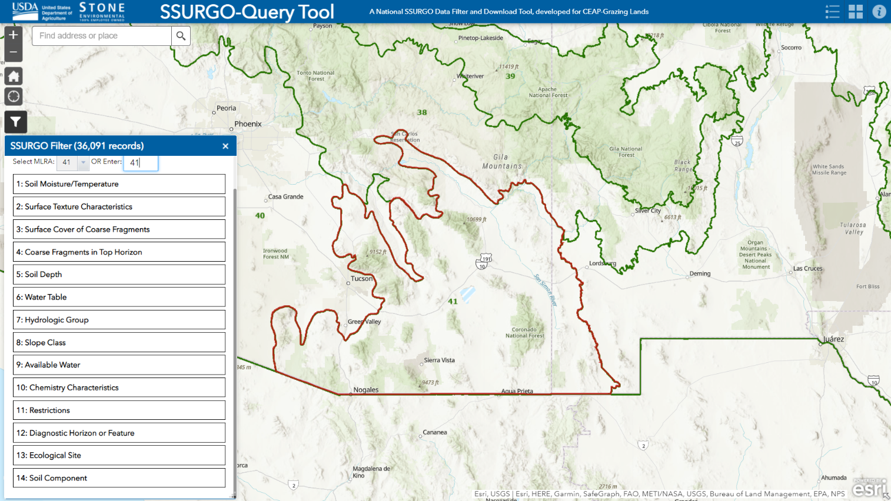**Figure 1.** Sample screenshot showing MLRA 41 selected, with filter criteria as provided at the time of review.